

|  |
| --- |
| HCL Technologies Ltd. |
| OpenXC Backend Interface – REST APIs |
|  |

# Architecture Overview

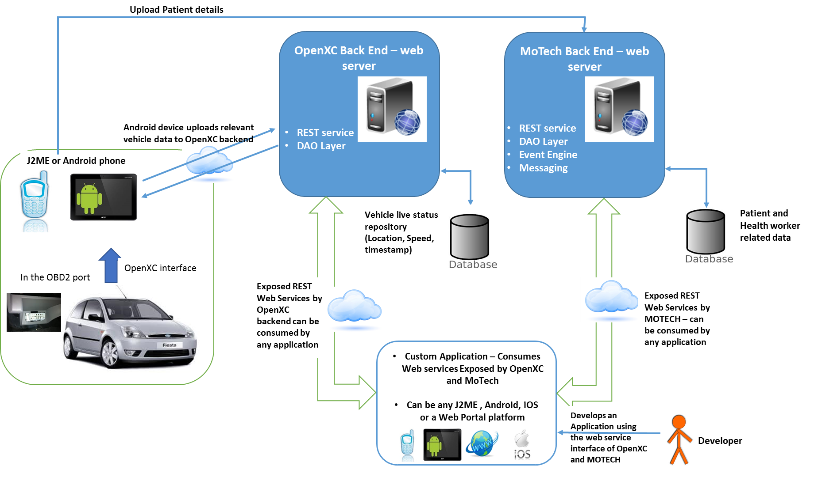A pictorial diagram on overview of integration solution –

**Highlights on above architecture**

* While travelling in-vehicle Health workers could have two mobile device (J2ME & Android) OR just one Android device, since MOTECH mobile app is supported both on J2ME and Android; while OpenXC App runs on Android device
* Both the devices will connect and interact with their respective backend (OpenXC Backend and MOTECH Backend) – mode of connection will be specific cellular network
* For India CommCare is the App that runs on Health worked mobile device (J2ME or Android) and provides relevant interface for patient registration and other details update. This App interacts with MOTECH Backend.
* Vehicle Data stream as received over OpenXC interface via OBD2 port VI, will be uploaded to OpenXC backed over provided interface.
* Developer could use both the web services interface (from OpenXC as well as from MOTECH) for leveraging vehicle data and Patient’s data – AND write his innovative Apps.

# Database Schema for OpenXC Backend

## Prerequisites

* **Database need to be used MySQL.**
* **Database credential are username = “root” and password =”mysql”**
* **Database schema name “mh_openxc_db”**

## Tables design for OpenXC backend

**Table Name**: vehicleregistrationdata_tb

CREATE TABLE `vehicleregistrationdata_tb` (  
  `vehicleId` int(8) NOT NULL AUTO_INCREMENT,  
  `vehRegnNo` varchar(100) NOT NULL,  
  `vehChasisNo` varchar(100) NOT NULL,  
  `vehMake` varchar(100) NOT NULL,  
  `vehModel` varchar(100) NOT NULL,  
  `contactNo` varchar(15) NOT NULL,  
  `emailId` varchar(100) NOT NULL,  
  `createdOn` datetime NOT NULL,  
  PRIMARY KEY (`vehicleId`)  
) ENGINE=InnoDB AUTO_INCREMENT=100046 DEFAULT CHARSET=utf8

**Table Name**: vehicleruntimedatarecord_tb

CREATE TABLE `vehicleruntimedatarecord_tb` (  
  `vehRunTimeId` int(6) NOT NULL AUTO_INCREMENT,  
  `vehicleId` int(8) NOT NULL,  
  `vehSpeed` float NOT NULL,  
  `latitude` varchar(40) NOT NULL,  
  `longitude` varchar(40) NOT NULL,  
  `timeStamp` datetime NOT NULL,  
  `address` varchar(1000) DEFAULT NULL,  
  PRIMARY KEY (`vehRunTimeId`)  
) ENGINE=InnoDB AUTO_INCREMENT=3624 DEFAULT CHARSET=utf8

# OpenXC Backend API Interface

**Set of APIs are that are supported in given WAR file are listed below:**

## registerVehicle()

|  |  |  |  |  |
| --- | --- | --- | --- | --- |
| **RegisterVehicle** | | | | |
| **Protocol** | HTTP - REST API | | | |
| **Description** | Send data to the OpenXC platform over http REST API. | | | |
| **Input Parameter** | Data Format : JSON data | ***vehRegnNo*** | | : String |
| ***vehChasisNo*** | | : String |
| ***vehMake*** | | : String |
| ***vehModel*** | | : String |
| ***contactNo*** | | : String |
| ***emailId***  : String | | |
| **Output** | Json String. | ***Response*** | **responseMsg** : (Y = Success, N = Failure, E= Exist) | |
| **vehicleId** :(will be blank if error) | |
| **errorMsg** : (will be blank if no error) | |

1. **uploadVehicleData**()

|  |  |  |  |
| --- | --- | --- | --- |
| **UploadVehicleData** | | | |
| **Protocol** | HTTP – REST API | | |
| **Description** | Send vehicle data to the OpenXC platform over http REST API. | | |
| **Input Parameter** | Data Format : JSON data | ***vehicleId***  : String | |
| ***vehSpeed*** | : String |
| ***latitude*** | : String |
| ***longitude*** | : String |
| ***timeStamp*** | : String (unix time stamp) |
| **Output** | Json String. | ***Response*** | **responseMsg** :(Y = Success, N = Failure, NE = Not Exist) : String |
| **errorMsg :** (will be blank if no error) : String |

## getVehicleCurrentLocation()

|  |  |  |  |
| --- | --- | --- | --- |
| **GetVehicleCurrentLocation** | | | |
| **Protocol** | HTTP - REST API | | |
| **Description** | Get data from OpenXC platform over http REST API. | | |
| **Input Parameter** | Data Format : JSON data | ***vehRegnNo***  : String | |
| **Output** | Json String. | ***latitude*** | : String |
| ***longitude*** | : String |
| ***address*** | : String |
| ***errorMsg***(will be blank if no error) | : String |

## getAllVechicleCurrentLocation()

|  |  |  |  |
| --- | --- | --- | --- |
| **GetAllVechicleCurrentLocation** | | | |
| **Protocol** | HTTP - REST API | | |
| **Description** | Get data from OpenXC platform over http REST API. | | |
| **Output** | Json String. | **vehicleList (jsonArray)** | **vehRegnNo** : String |
| **latitude** : String |
| **longitude** : String |
| **address** : String |
| **errorMsg : (will be blank if no error) :** | String |

## showRoute ()

|  |  |  |  |
| --- | --- | --- | --- |
| **ShowRoute** | | | |
| **Protocol** | HTTP - REST API | | |
| **Description** | Get data from OpenXC platform over http REST API. | | |
| **Input Parameter** | Data Format : JSON data | ***vehRegnNo*** | String |
| **Output** | Json String. | **routeList (jsonArray)** | **latitude** : String |
| **longitude** : String |
| **errorMsg** (will be blank if no error) : | String |

## getRegisteredVehicleList ()

|  |  |  |  |
| --- | --- | --- | --- |
| **GetRegisteredVehicleList** | | | |
| **Protocol** | HTTP - REST API | | |
| **Description** | Get data from OpenXC platform over http REST API. | | |
| **Output** | Json String. | **vehicleList (jsonArray)** | ***vehicleId*** : String |
| ***vehRegnNo*** : String |
| ***vehChasisNo***  : String |
| ***vehMake***  : String |
| ***vehModel***  : String |
| ***emailId***  : String |
| ***contactNo***  : String |
| ***createdOn***  : String |
| **errorMsg** (will be blank if no error) : | **String** |

**~~ end of doc ~~**